Park School

Online Safety Newsletter: October 2019

Netflix

Does your child watch Netflix? You can add a PIN to your account so a 4-digit PIN must be entered to either play any TV show or movie above a selected maturity level (on all profiles) or to play a specific TV series or movie (on all profiles).

Alternatively, you can create up to 5 personalised profiles in your Netflix account for each member of the household. You can then choose a maturity level for each profile to control the TV shows and movies they can view.

For younger children, you could create a child profile which only includes content appropriate for children.

Find out more here:
https://help.netflix.com/en/node/264
Nintendo Switch

Nintendo Switch (and the newer Switch Lite which launched last month) offers lots of fun and age appropriate games to play and by setting up appropriate controls, it can offer a safe and fun environment to play games.

What is Nintendo Switch Online?
This is a paid service that allows the user to play online by linking to other Switch consoles. Nintendo’s guidance states ‘this service should not be used by account users who are under 13 years old’. Due to its online nature, children could be playing games with people they don’t know which has risks such as being exposed to inappropriate language. If you do choose to purchase this service for your child then set up the appropriate controls detailed below.

Parental Controls App
There is a Nintendo Switch Parental Controls app available which is free to download to your phone (or other smart device) which you can then link to your child’s Nintendo Switch in order to monitor what they are playing. You can also set some restrictions on the Nintendo Switch. You can use the app to:
- see what video games your child has been playing
- how long your child has been playing for and set time limits
- set which games can be played based on their PEGI age rating
- turn off voice chat
- restrict spending in the Nintendo eShop

Further information
For further information and guidance, visit the following links:
Users of this guide do so at their own discretion. No liability is entered into. Current as of the date released 1.10.19.

Users of this guide do so at their own discretion. No liability is entered into. Current as of the date released 1.10.19.

- https://www.nintendo.co.uk/Nintendo-Switch/Nintendo-Switch-Parental-Controls/Nintendo-Switch-Parental-Controls-1183145.html
- https://www.commonsensemedia.org/blog/parental-controls-nintendo-switch
Users of this guide do so at their own discretion. No liability is entered into. Current as of the date released 1.10.19.

Users of this guide do so at their own discretion. No liability is entered into. Current as of the date released 1.10.19.

Users of this guide do so at their own discretion. No liability is entered into. Current as of the date released 1.10.19.

Digital Wellbeing

We all need to be aware of how being online can affect us and look after our digital wellbeing. Childnet have further information about what digital wellbeing is as well as how you can support your child’s digital wellbeing tailored to their age:

What is Sexting?

Sexting is sending an explicit image or video of yourself to somebody else. It can also be called ‘pic for pic’ or ‘nude selfies’.

The risks
Once you send an image/video you no longer have control of it, it could be posted online or shared with others. Remember that even if you use an app like SnapChat to share an image, somebody could take a screenshot of it and share it with others.

Start a conversation
We understand that some conversations can be awkward but it’s important to chat to your child about the potential risks of sharing explicit images, the law and where they can get help. Perhaps start the conversation by relating it to something in the news. Ensure that they know they can talk to you.
https://www.childnet.com/parents-and-carers/hot-topics/digital-wellbeing
Social Media top Tips

Internet Matters have produced the following document which includes their top tips for parents in guiding your child to be safe whilst using social media.

https://www.internetmatters.org/resources/social-media-top-tips-cards/

The law
It is actually illegal to create or share an explicit image of a child (under 18), even when the person doing so is a child themselves. It’s important to remember that the age in relation to taking explicit images is 18. You are breaking the law if you:
- take an explicit photo or video of yourself or a friend.
- share an explicit image or video of a child.
- possess, download or store an explicit image or video of a child.

N.B. If under-18s are found to be engaging in sexting, then whilst the matter will be investigated, police can choose to record that a crime has been committed but that taking formal action isn't in the public interest.

What to do if a nude or nearly nude image is shared online
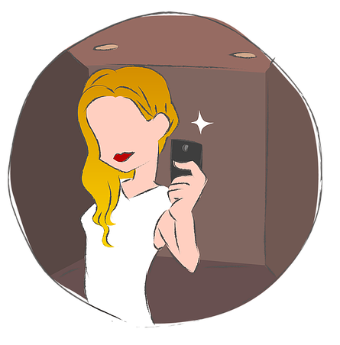
There are steps you can take to alleviate the situation including ways in which to minimise the distribution of such images. Childnet have simply detailed this here:
https://www.childnet.com/parents-and-carers/hot-topics/sexting/taking-positive-action

Further information
There’s lots more advice available online about sexting, for example what to do if your child has been affected by this. Our school will also be able to advise and guide you should you need us and there are other organisations that you can turn to such as:
- https://www.childline.org.uk/info-advice/bullying-abuse-safety/online-mobile-safety/sexting/
- https://www.childnet.com/parents-and-carers/hot-topics/sexting
- https://www.nspcc.org.uk/preventing-abuse/keeping-children-safe/sexting/

