Park School

Online Safety Newsletter: July 2019

PEGI ratings explained

If you see this rating on a game then it means the game refers to or depicts the use of illegal drugs, alcohol or tobacco. Games with this content descriptor are always PEGI 16 or PEGI 18 meaning you should be over 16 or 18 years of age to play the game.
More control over your broadband

Do you have Vodafone or Virgin Media Broadband? If yes, they have their own apps which give you further control over your internet access.

Vodafone Broadband App
- View and manage all devices on your network.
- Control when your Wi-Fi is on.
- Receive notifications when devices join your network for the first time.

Virgin Media Connect App
- See how many devices are connected to your WiFi.
- Pause access to the internet for particular devices.
Parent Zone crisis messenger

Parent Zone have launched a new service: Crisis Messenger text service which provides free, 24/7 support across the UK. If you are experiencing a mental health crisis and need support, you can text PARENTZONE to
85258.

Further information available here:
https://parentzone.org.uk/parent-zone-crisis-messenger
TikTok Update (users must be 13+)

What is TikTok? Users can watch musical clips, record 60 second clips, edit them and add special effects. You must be over 13 years of age to use it so if you do choose to allow your child to set up an account then we recommend users have a private account to control who can see their videos and who can send them messages. Tik Tok also includes a ‘Restricted mode’ to limit the appearance of content that may be inappropriate. More information is available here:

http://support.tiktok.com/?ht_kb=for-parents

Parent Zone have recently updated their website with a full summary of what TikTok is and how it can be used more safely so we would highly recommend reading this if your child does use TikTok:

https://parentzone.org.uk/article/tiktok-everything-you-need-know-about-video-production-app
Does your child have an Apple Device?

Have you set up Family Sharing with Apple? Family Sharing allows you to create an Apple ID for those under 13 (they are not allowed to do it themselves) or for children over 13 who have already set up their ID, you can add it to your family group. Once set up, you can limit what content your child can access and also enable ‘Ask to Buy’ (enabled by default for children under 13 and you’ll be asked to set it up when adding anyone 13 – 18 years of age.)

With Ask to Buy, whenever a child tries to purchase or download something (from iTunes, Apple Books, App Store, In-App Purchases, or iCloud storage), a request will be sent to you to review and either approve or decline the request.

Further information to set up Family sharing and an Apple ID is available here:
https://support.apple.com/en-gb/HT201084

LIKEE App (formerly LIKE Video) 16+

Rated as 17+ on the App store

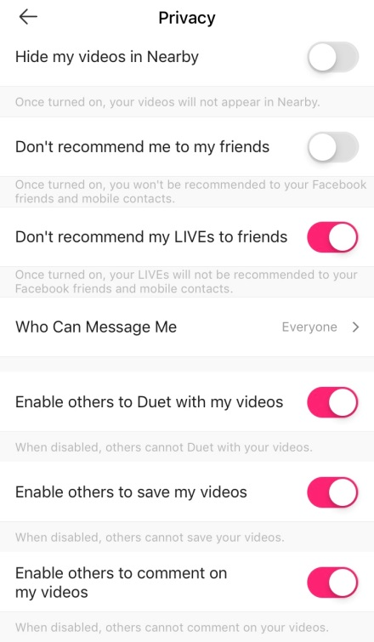
LIKEE, which has recently rebranded from LIKE, is a short video editor and video sharing app. It has over 200 million users worldwide. The app allows users to create and edit videos and to add emoji stickers and face filters. Due to the age of people accessing this app, suggestive content can be found on here.
Privacy Settings
All profiles on LIKEE are public which means that everything your child posts on there can be seen by others. The app also includes private messaging.

If your child does use this app then there are several privacy options which we would recommend reviewing:
- who can message me: set to ‘friends’ or ‘disable’
- enable others to save my video: Likee allows other users to download other people’s videos (which they can then share/upload to other places) so we would strongly recommend disabling this option.
- enable others to comment on my videos: if disabled then others cannot comment on your video.
Blocking Users
This app does give users the ability to block other users so like with everything your child accesses online, make sure your child understands how to do this.
In-app purchases
You must be aware that whilst this app is free to download, additional in app purchases in the form of diamonds can be made, ranging from £0.99 – £99 per item! They’re very easy to purchase with one tap and then a confirmation tap.

Further information
Common Sense Media have produced a further review about this app here:
https://www.commonsensemedia.org/app-reviews/like-magic-music-video-editor

