Park School

Online Safety Newsletter: September 2019

Games to play as a family

It is important to take an actve role in your child’s online life and playing games online with them is a great way to do this whilst demonstrating to your child good gaming habits. Internet Matters have compiled this list of games that you could play together based on your child’s age.

https://www.internetmatters.org/resources/online-gaming-advice/amazing-video-games-guide-for-families/

Instagram: new anti-bullying tool

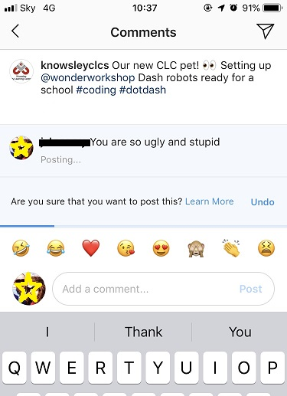
Instagram is now using Artificial Intelligence to recognise when a message being typed is one that would quite often be reported as inappropriate so a user might try to send a comment “you are so ugly,” but a message appears saying ‘Are you sure that you would like to post this?’ with the option to learn more or undo. The feature has been designed to encourage more positive interactions on Instagram. Discuss this with your children and explain what it’s there for. Further information is available here:
https://instagram-press.com/blog/2019/07/08/our-commitment-to-lead-the-fight-against-online-bullying/

Childnet answer parents most frequently asked questions about Instagram here:

https://www.childnet.com/blog/answering-parents-most-frequently-asked-questions-about-instagram
Users of this guide do so at their own discretion. No liability is entered into. Current as of the date released 1.9.19.

What is skin gambling?

Skins are virtual items in games that can be won or purchased and are used to customise weapons. There are websites that let players gamble their skins. Find out more here:
https://parentinfo.org/article/skin-gambling-what-parents-should-know
What is clickjacking?

Where somebody maliciously tricks a user into clicking on a link which could result in downloading malware or sharing confidential information. Find out more here:
https://www.getsafeonline.org/safeguarding-children/clickjacking/

In app purchases

Lots of apps/games are free to download/access but then contain in app purchases.

To prevent purchasing on your child’s iPhone or iPad follow these instructions:
https://support.apple.com/en-gb/HT204396

To prevent purchasing through Google Play follow these instructions:
https://support.google.com/googleplay/answer/1626831
PEGI ratings explained

If you see this rating on a game then it means the game contains bad language. This descriptor can be found on games with a PEGI 12 (mild swearing), PEGI 16 (e.g. sexual expletives or blasphemy) or PEGI 18 rating (e.g. sexual expletives or blasphemy).

Sky Broadband Buddy

Do you use Sky Broadband? If so, this app allows you to manage each screen in your home. The app allows you to create different filters i.e. PG, 13 or 18 so they don’t see something that they shouldn’t. It allows you to set Time Limits, schedule Off Time as well as view what each member has been doing online. Further information is available here:

https://www.sky.com/help/diagnostics/sky-broadband-buddy/sky-broadband-buddy

Fortnite (Rated PEGI 12)

Fortnite is still very popular with lots of young people. It is rated PEGI 12 for frequent mild violence which means it is not suitable for persons under 12 years of age. It is important to bear in mind that when rating games, PEGI do not take into consideration the chat features of a game which Fortnite does include.

What do you need to be aware of?

Chat functionality:
Fortnite contains voice and text chat which can contain inappropriate language. You can turn the voice chat off but not the text chat. To turn voice chat off, go to Settings, Audio and switch to off. As always, show your child how to report players for any inappropriate behaviour (they can use the in-game feedback tool in the main menu, more information can be found here: https://epicgames.helpshift.com/a/fortnite/) and ensure that they know that they should talk to you or another trusted adult if they have any concerns.

In app purchases:
All users can purchase V-Bucks directly through the game. This currency can be used to purchase items in the Fortnite store so make sure you don’t store your credit card details.

We always recommend playing the game with your child so you can see what they are playing and monitor the sort of chat that they are listening to/contributing to.

For further information about Fortnite, Parentzone have produced this great article:
https://parentzone.org.uk/article/fortnite-everything-you-need-know-about-online-game
Using Google Play store

Does your child use the Google Play store? If so, have you set up appropriate parental controls? Parental controls allow you to restrict content based on your child’s maturity level so you can set up parental controls for e.g. apps, games and TV shows to prevent your child from downloading items that are above the rating that you set. Further information is available here:

https://support.google.com/googleplay/answer/1075738?hl=en-GB

